Gluten Free Please
Total # snacks needed:
Monday = 8 Tuesday = 16
Friday = 8 Thursday = 16
Wednesday = 16

Keep snacks healthy.
(See Approved Snack List)
Don’t forget napkins.
Please do not send a drink.
We will provide milk/water.
(Birthdays are an exception)
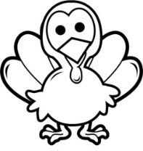
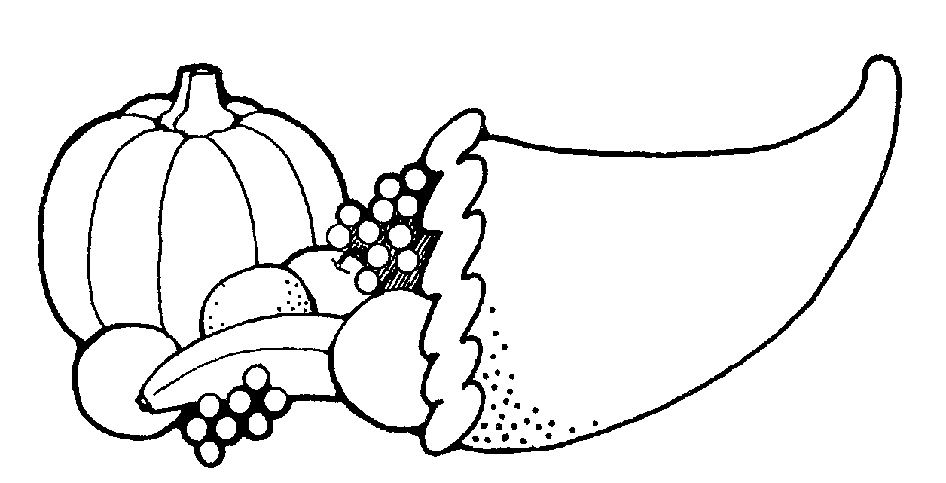
Preschool Snack Calendar
Sunday | Monday | Tuesday | Wednesday | Thursday | Friday | Saturday
 |  |  |  |  | 1  No School | 2
3 | 4 | 5 | 6 | 7 | 8 | 9
10 | 11 | 12  Happy Birthday Luis! | 13 | 14 | 15 | 16
17  Preschool, Pre-K and Kindergarten Family Mass 11:30 | 18 | 19 | 20 | 21 | 22 | 23
24 | 25 | 26 | 27  No School | 28  No School  Happy Thanksgiving! | 29  No School | 30
November

